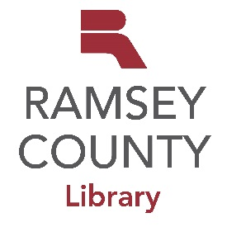
Programming Partnership Proposal

Thank you for your interest in providing programming for our community. Your proposal will be evaluated on how well it aligns with the library’s strategic plan, programming goals, and the availability of library resources. Library programming efforts are planned at least eight weeks in advance of the event date.

Program Title/Topic: ________________________________________________________________

Presenter Name: ___________________________________________________________________

Agency/organization (if applicable): ____________________________________________________________________________________

Desired Date: _________________________ Program Length: ____________________________

Fee Required: ______________________________

Type of Program: Class or instruction Entertainment or performance

Target Audience: Babies Preschool Ages 6-12 Teens Children All ages

If Adult, Program Category: Arts/Literature Community Well-Being
Digital Literacy/Makerspace Financial/Legal Health/Wellness
History Jobs/Small Business Science/Nature Other: ________________________

Preferred Branch: MP MV NB NS RV SV WB

Anticipated Audience Size: 40-100 25-39 15-24 15 or fewer Don’t know

Please provide a detailed description of the program and include the qualifications of the presenter(s) or reviews of program content:

Describe your goals in presenting the proposed program:

What is the intended impact on participants?

How will you help promote this program?

Are you interested in having the program recorded and streamed and do you have permission from all content providers to do so?
Yes No

Presenters are not allowed to solicit funds, personal information, or promote commercial services. It is acceptable to make available promotional materials about the organization on a table at the back of the program. I agree

Contact person: ___________________________________________________________________

Contact Email address: _____________________________________________________________

Phone Number: _______________________________________

For adult programming, please email this form to Paul Lai: paul.lai@co.ramsey.mn.us
For children’s programming, please email this form to Ann Wahlstrom: ann.wahlstrom@co.ramsey.mn.us
For teen programming, please email this form to Erica Redden: erica.redden@co.ramsey.mn.us

